**TotalAgility Connector for UiPath With Instructions and Samples**

**Date: 2021-09-01**



© 2020 Kofax. All rights reserved. Maintained by Adam Sawyers (adam.sawyers@kofax.com)

Kofax is a trademark of Kofax, Inc., registered in the U.S. and/or other countries. All other trademarks are the property of their respective owners. No part of this publication may be reproduced, stored, or transmitted in any form without the prior written permission of Kofax.

Table of Contents

Preface 4

Prerequisites 5

Initial sample setup 6

Import processes to TotalAgility 6

Import KTA Maps for UiPath Packge.zip 6

Import Capture Starter Pack Package.zip 7

Upload packages to UiPath Orchestrator 9

Add images 14

View UiPath projects 14

Sample test execution 15

Checklist 15

Test execution 1 15

Test execution 2 16

Test execution 3 17

Test execution 4 18

**3**

Preface

This document explains how to integrate Kofax TotalAgility with Robotics Process Automation (RPA) ‘UiPath’.

**4**

Prerequisites

* Kofax TotalAgility 7.7 and above Installed on any server.
* UiPath 2019.10 installed with Orchestrator (OP), Studio & Robot running on a server.
* UiPath Sample Package.Zip. This ZIP file includes the following items:
* DemoBot.1.0.8.nupkg: UiPath process
* QueueBot.1.0.8.nupkg: UiPath process
* CaptureBot.1.0.7.nupkg: UiPath process
* ExceptionManagementBot.1.0.10.nupkg: UiPath process
* KTA UiPath Connector.zip: TotalAgility processes
* Capture Starter Pack Package.zip: TotalAgility process
* Order1.tif: Sample invoice image
* Order2.tif: Sample invoice image
* UiPath Projects.Zip: Contains all the UPath Studio Project files for the above UiPath processes.

**5**

Initial sample setup

This section provides the detailed steps to set up the sample.

Import processes to TotalAgility

Open the TotalAgility Designer via browser. (Example: **http://<Server>/TotalAgility/ Designer/**). The logon screen appears to login or the Home screen appears (if using windows authentication).

Import KTA Maps for UiPath Packge.zip

**1.** Click the **Import** menu option in TotalAgility Designer.

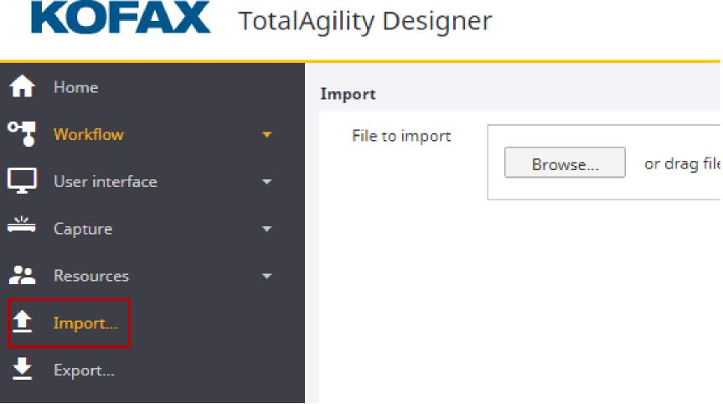

**6**

Sample for TotalAgility integration with UiPath

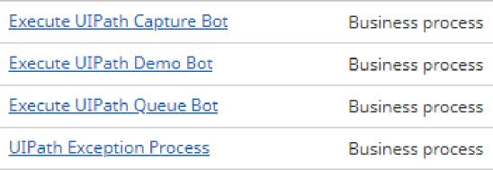

1. Browse and select **KTA UiPath Connector.zip**.   
   A list of package artifacts is displayed.

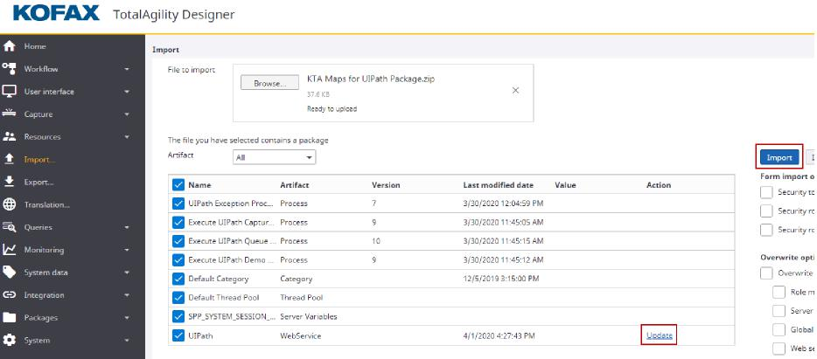

1. Click the **Update** link for UiPath WebService artifact in the list and update the **URL** field with your Orchestrator URL (Example: <https://server.domain.com/).>

**Note** This is the UiPath orchestrator URL that will be used across the Jobs for API calls.

1. Click **Import** to import all the artifacts.

The following TotalAgility business processes are imported:

Import Capture Starter Pack Package.zip

Import **Capture Starter Pack Package.zip** into TotalAgility in the same way as you imported **KTA Maps for UiPath Packge.zip**.

Once imported, you should find the processes under Capture Starter Pack category.

In case, you have not updated the orchestrator URL in the webservice reference during the Import, you can also update it in the Web service references settings under **Integration** menu option in TotalAgility Designer. Open the UiPath reference and update the correct orchestrator URL in the **URL** field and **Save**.

**7**

Sample for TotalAgility integration with UiPath

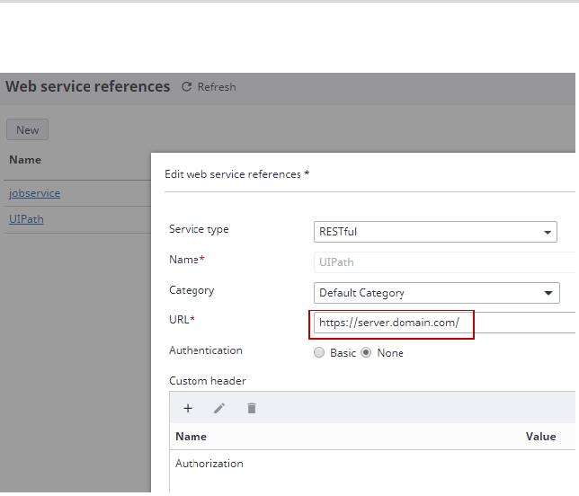

Service type Name* Category

URL*

Authentication Custom header

RESTful

UlPath

Default Category

https://server.domain.com/

0 Basic 0 None

Web service references C

Refresh

New

Name

Edit web service references *

**+**

**Name Value**

Authorization

**8**

Sample for TotalAgility integration with UiPath

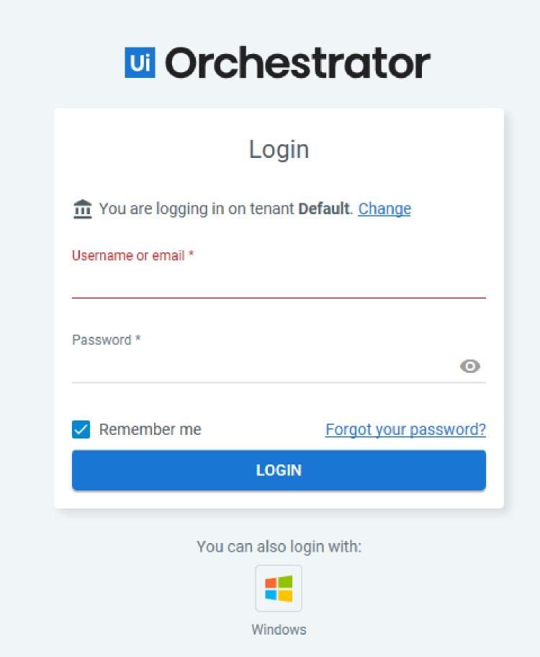

Upload packages to UiPath Orchestrator

Upload processes to UiPath Orchestrator.

1. Open the UiPath Orchestrator via browser. (Example: https://server.domain.com/ ). The Orchestrator logon screen appears.
2. Login using valid credentials.

**9**

Sample for TotalAgility integration with UiPath

1. Click **PACKAGES** under **MANAGEMENT**.

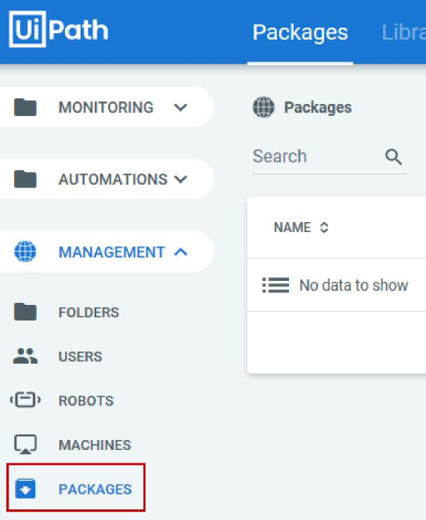

1. Click on the **Upload** Icon on the right and browse for all the four UiPath processes (DemoBot, QueueBot, CaptureBot, ExceptionManagementBot).

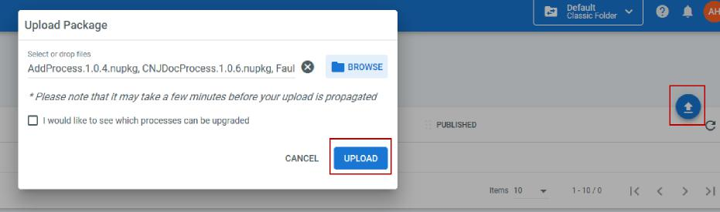

**10**

Sample for TotalAgility integration with UiPath







1. Click **UPLOAD** to upload the processes.

The following UiPath processes are imported under **Packages**:

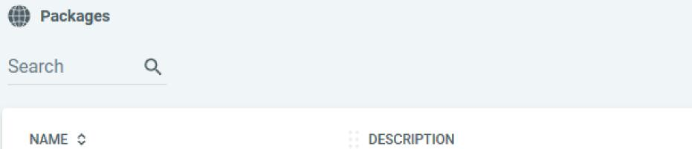





1. To deploy these processes, go to **PROCESSES** menu under **AUTOMATION**.

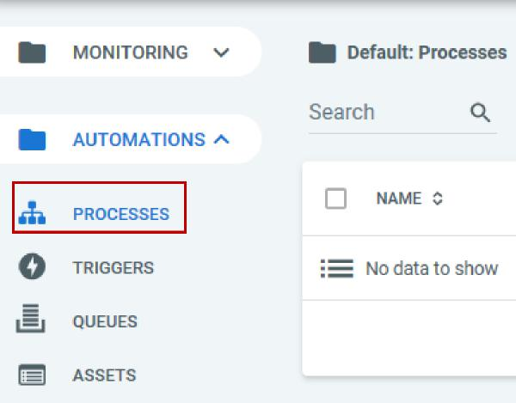

**11**

Sample for TotalAgility integration with UiPath

**7.** Click on ‘+’ icon on the right and select each of the UiPath process (DemoBot, QueueBot, CaptureBot, ExceptionManagementBot).



Default: ProG Search

NAME

No data to



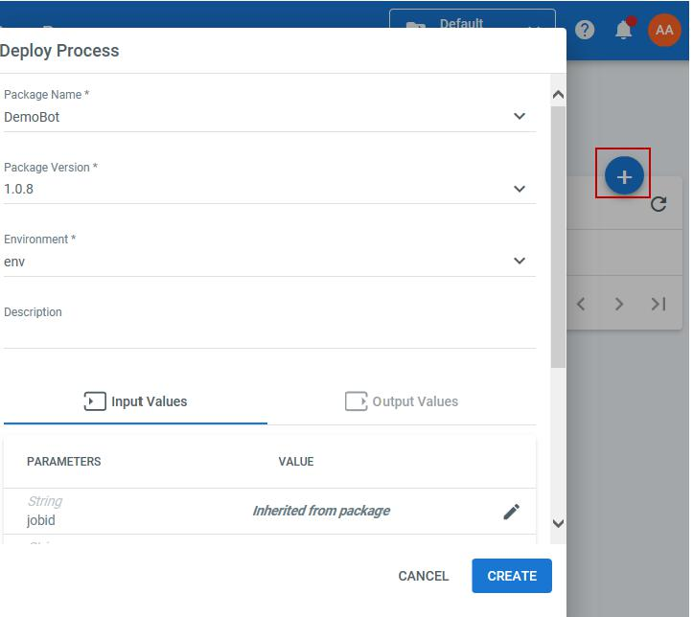

jobid

*Inherited from package*

V

CANCEL

CREATE

Deploy Process

Package Name *

DemoBot

Package Version *

1.0.8

Environment * env

Description

Input Values E Output Values

PARAMETERS VALUE

**12**

Sample for TotalAgility integration with UiPath

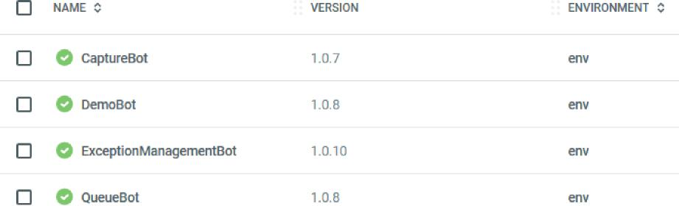

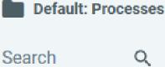

**8.** Click **CREATE** to deploy the processes.

The following UiPath processes appear under **Processes**:

1. Go to the UiPath Server where the Robot is installed.
2. Open UiPath Robot either from the start programs or the taskbar icons. The processes are seen in the Robot screen.

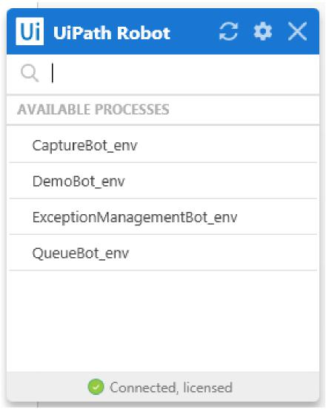

1. Click on the **Update** icon against each available process to make the processes ready for testing.

**13**

Sample for TotalAgility integration with UiPath

Enable External Application Authentication

Open the TotalAgility Designer via browser. (Example: **http://<Server>/TotalAgility/ Designer/**). The logon screen appears to login or the Home screen appears (if using windows authentication).

Create Client Keys in UiPath Orchestrator

1. Login to UiPath Cloud (cloud.uipath.com)
2. Navigate to Admin (left side vertical menu)
3. Navigate to External Applications (one menu to right of previous step)
4. Add application and name it something sensible (e.x. "TotalAgility")
5. Keep application type as "Confidential"
6. Click add scopes
7. Select orchestrator API access from Resources dropdown (right side top of screen on the modal/pop up menu)
8. **Click Application Scope(s) and select the necessary scopes for what you need and WRITE THEM DOWN (see below if unsure)**
9. Click Save on the menu
10. Redirect URL is not used, so enter something like your company's website (e.x. "https://kofax.com")
11. Click Add (bottom right of screen)
12. **COPY BOTH APP ID and APP SECRET** on the modal/pop-up (this is the only time you will see the secret)

Store Client Keys Securely In KTA

1. When you import the package, ensure you set your REST API endpoint (see page 7 for more info)
2. Create a string server variable for app ID, secret, and scopes (multiple scopes should be separated by a space, e.x. "OR.Machines OR.Folders OR.Admin")
   1. Recommended to use the server variable **extAppId** which is already created for you
3. Set app ID from step 12 as the **extAppId** in the server variable
   1. In the TotalAgility Designer, System Data > Server Variables > Category = **UiPath Connector**
4. Set app secret from step 12 as the **extAppSecret** server variable
5. Set the scopes from step 8 as the **apiScopes** server variable
6. In your process, make sure you have the proper authentication method necessary for your solution
   1. It’s the first Decision block in each process
   2. Set to **TRUE** if using External Application or **FALSE** if not

Add images

On the UiPath server, create a new folder ‘Images’ under c: drive and copy the Order1.tif & Order2.tif images into this folder.

View UiPath projects

You can view all the UiPath processes (design time) using the UiPath Studio.

1. Unzip the **UiPath Projects.zip** to a folder.
2. Open the .xaml files for each of the process you need using the **UiPath Studio** > **Open** menu.

**14**

Sample test execution

This section provides the detailed steps to test this sample.

Checklist

1. On the UiPath server, make sure the UiPath robot is successfully connected to the orchestrator and running.

Details of UiPath server used for this sample:

Orchestrator Url: https://server.domain.com/ (IP: 172.x.x.x)

username: Domain\Administrator

password: password

Unattended Robots names: robot1 , robot2

1. Make sure the orchestrator URL is accessible from your TotalAgility server. If using the sample server, you need to add the following text to your host file:

172.x.x.x [server.domain.com](http://server.domain.com)

1. As HTTPS protocol is mandatory for all communication between Robots and Orchestrator, make sure you have the valid certificate on your TotalAgility server. If using the sample server (hv-uipathdemo), you can install an SSL certificate created on the server, such as UIPATH_For_Hv-uipathdemo.cer’ or update the IgnoreCertificateError setting to true in TotalAgility/coreworker configuration files.

Test execution 1

In this test, TotalAgility will execute a bot within UiPath by passing data as input parameters and wait for the bot to return output data which will complete the TotalAgility job.

**Note** The bot would just add two strings and return the result.

**1.** Open the TotalAgility workspace via browser. (Example: http://<TotalAgilityServer>/ TotalAgility/Forms/). The logon screen appears where you can log in or the Work queue screen appears, if using windows authentication.

**15**

Sample for TotalAgility integration with UiPath

1. Click **Jobs** > **Create**.



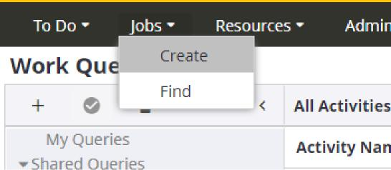

1. Create a job on ‘Execute UiPath Demo bot’ process by passing the following Initialization parameters.

|  |  |  |
| --- | --- | --- |
| **Variable name** | **Description** | **Sample value** |
| UIPathInput1 | <Input String one> | FirstName |
| UIPathInput2 | <Input String two> | Last Name |
| Robot Name | Name of Robot to run the job on | robot1 |
| UIPathProcessName | Name of UiPath process to start the UiPath job on. | Demobot |
| KTA Endpoint | Endpoint For Raise Event API that  will be called by robot. Replace the  <TotalAgilityServer> with correct value. | http://<TotalAgilityServer>/TotalAgility/ Services/SDK/JobService.svc/json/ RaiseEvent |
| Authentication Data | Replace the <username>, <password> which is needed for UiPath API calls. Make sure the username has a ‘\\’ if using domain name. Example: Domain\ \Administrator | { "usernameOrEmailAddress":  "<Username>", "tenancyName": "Default", "password": "<password>" } |

This job will execute ‘Demobot’ on the robot1 which will add the two strings and raise a TotalAgility event which should update the ‘OUTPUT’ variable in the ‘Execute UiPath Demo bot’ job.

1. Open the job details by clicking on the newly created job ID and check the Job details screen.

The job status in the Job details screen should be ‘Completed’ and the OUTPUT variable (in Variable tab) must be updated with Concatenated string (example: FirstName LastName).

Test execution 2

In this test, TotalAgility executes a bot within UiPath by passing data using UiPath Queues and waits for the bot to return output data which completes the TotalAgility job.

**16**

Sample for TotalAgility integration with UiPath

**Note** The bot would just add two strings and return the result.

1. Open the TotalAgility workspace via the browser as stated in Test execution1.
2. Create a job on ‘Execute UiPath Queue Bot’ process by passing the following Initialization parameters.

|  |  |  |
| --- | --- | --- |
| **Variable name** | **Description** | **Sample value** |
| UIPathInput1 | <Input String one> | FirstName |
| UIPathInput2 | <Input String two> | Last Name |
| Robot Name | Name of Robot to run the job on | robot1 |
| UIPathProcessName | Name of UiPath process to start the UiPath job on. | QueueBot |
| KTA Endpoint | Endpoint For Raise Event API that will be called by robot. Replace the <TotalAgilityServer> with the correct value. | http://<TotalAgilityServer>/TotalAgility/ Services/SDK/JobService.svc/json/ RaiseEvent |
| Authentication Data | Replace the <username>, <password> which is needed for UiPath API calls. Make sure the username has a ‘\\’ if using domain name. Example: Domain\ \Administrator | { "usernameOrEmailAddress":  "<Username>", "tenancyName": "Default", "password": "<password>" } |

This job will execute ‘QueueBot’ on the robot1 which will add the two strings and raise a TotalAgility

event which should update the ‘OUTPUT’ variable in the ‘Execute UiPath Queue Bot’ job.

Test execution 3

In this test, TotalAgility will execute a bot within UiPath which fails to execute and keeps the TotalAgility job waiting to be completed. A trigger job assigned to waiting activity will be raised (set for 4 mins due) and if the bot fails, it will suspend the parent job and the job note is updated with reason for bot failure.

1. Open the TotalAgility workspace via the browser as stated in Test execution1.
2. Create a job on ‘Execute UiPath Queue Bot’ process by passing the following Initialization parameters.

|  |  |  |
| --- | --- | --- |
| **Variable name** | **Description** | **Sample value** |
| UIPathInput1 | Ignore this parameter | FirstName |
| UIPathInput2 | Ignore this parameter | Last Name |
| Robot Name | Name of Robot to run the job on | robot1 |
| UIPathProcessName | Name of UiPath process to start the UiPath job on. | ExceptionManagementBot |
| KTA Endpoint | Ignore this param | http://<TotalAgilityServer>/TotalAgility/ Services/SDK/JobService.svc/json/ RaiseEvent |

**17**

Sample for TotalAgility integration with UiPath

|  |  |  |
| --- | --- | --- |
| **Variable name** | **Description** | **Sample value** |
| Authentication Data | Replace the <username>, <password> which is needed for UiPath API calls. Make sure the username has a ‘\\’ if using domain name. Example: Domain\ \Administrator | { "usernameOrEmailAddress":  "<Username>", "tenancyName": "Default", "password": "<password>" } |

This job will execute ‘ExceptionManagementBot’ on the robot1 which will fail to complete with a job state as ‘Faulted’.

1. In TotalAgility Workspace, wait for 4-5 minutes for the trigger map ‘UiPath Exception Process’ to be fired, which should suspend ’Execute UiPath Demo Bot’ and complete successfully.
2. Check the job details of ’Execute UiPath Demo Bot’ job.

The job status in the Job details screen should be ‘Suspended’ and the Notes tab should have an entry with the fault reason (you should see a parsing error).

Test execution 4

In this test, TotalAgility will execute a bot within UiPath which fails to execute and keeps the TotalAgility job waiting to be completed. A trigger job assigned to waiting activity will be raised (set for 4 minutes due) and if the bot fails, it will suspend the parent job and the job note is updated with reason for bot failure.

In this test, TotalAgility will execute a bot within UiPath which starts a job in TotalAgility by passing two documents which would be classified and have some minimal data extracted.

**Note** The two documents(Order1.tif and Order2.tif) are pulled from UiPath server location as mentioned in Add images.

1. Open the TotalAgility workspace via the browser as stated in Test execution1.
2. Create a job on ‘Execute UiPath Capture Bot’ process by passing the following Initialization parameters.

|  |  |  |
| --- | --- | --- |
| **Variable name** | **Description** | **Sample value** |
| Robot Name | Name of Robot to run the job on | robot1 |
| UIPathProcessName | Name of UiPath process to start the UiPath job on. | CaptureBot |
| KTA Endpoint | Endpoint for CreateJobWithDocuments API that will be called by robot. Replace the <TotalAgilityServer> with correct value. | http://<TotalAgilityServer>/TotalAgility/ Services/SDK/JobService.svc/json/ CreateJobWithDocuments |

**18**

Sample for TotalAgility integration with UiPath

|  |  |  |
| --- | --- | --- |
| **Variable name** | **Description** | **Sample value** |
| Authentication Data | Replace the <username> and  <password> which is needed for UiPath API calls.  Make sure the username has a ‘\\’ if using domain name. Example: Domain\ \Administrator | { "usernameOrEmailAddress":  "<Username>", "tenancyName": "Default", "password": "<password>" } |

This job will execute ‘CaptureBot’ on the robot1 which in turn will create a new job on ‘Capture Starter Pack’ by passing in the two documents from ‘c:\Images\’ folder.

**3.** Go to Work queue form in TotalAgility Workspace and you should see a ‘Document Review’ activity pending. Taking this activity should open the Capture form for review with two documents in it. Completing this form should take you to Work queue form with validation and verification activities pending for further processing.

**19**